**Meet our new Innovation Community: EIT Manufacturing!**

**News 12/11/2019**

[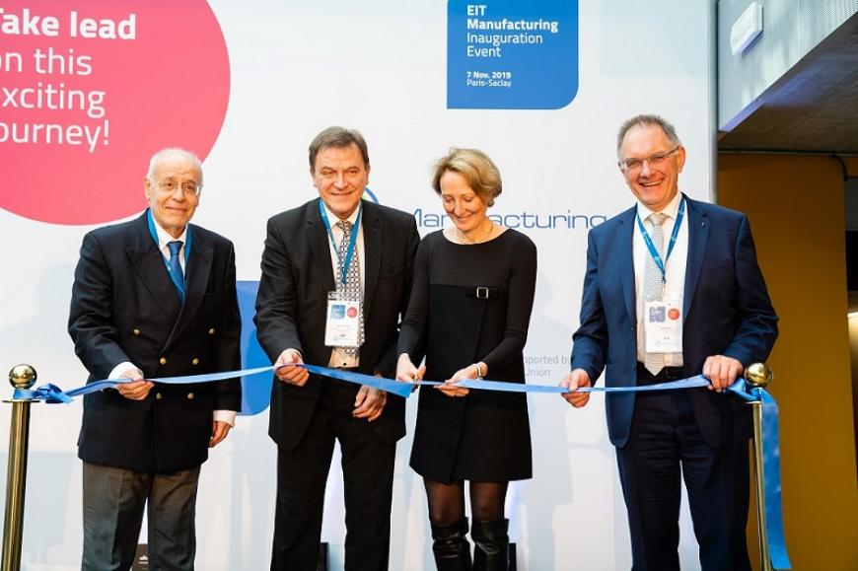](https://eit.europa.eu/sites/default/files/eit_manufacturing_event.jpg)

**On 07 November 2019, EIT Manufacturing hosted its Inauguration Event in its Paris-Saclay Headquarters, at the Centre d’Intégration Nanoinnov.**

The event announced the official launch of the most recent Innovation Community of the EIT, which connects leading manufacturing actors in Europe through a network of 50 partners.

For the formal session, the initiative gathered representatives from the [European Comission](https://ec.europa.eu/info/index_en), from the Paris Region and from the [EIT Governing Board](https://eit.europa.eu/who-we-are/governing-board/meet-gb), among the more than 150 attendees.

The opening was made by Heinrich Flegel, EIT Manufacturing Chairman, and speeches were delivered by Agnès Paillard, EIT Governing Board Member, Gintaras Vilda, Vice-Minister of Economy and Innovation of the Republic of Lithuania, and Isabelle Perdereau, Regional Minister and President of the Commission for Economic Development and Innovation of the Paris Region, which highlighted the important role of EIT Manufacturing as a new member of the EIT Community.

**Synergies between European initiatives for a world-leading European manufacturing sector**

A panel discussion took place afterwards under the subject 'Synergies between European initiatives for a world-leading European Manufacturing sector'. Among the participants were five representatives from the European Commission’s Directorates-General, namely Begoña Arano (Head of Unit at DG EAC), Jürgen Tiedje (Head of Unit at DG RTD), Max Lemke (Head of unit at DG CONNECT), Olivier Chassagne (Policy officer at DG GROW) and Pierre Henry (Team leader at DG ENV). Klaus Beetz (EIT Manufacturing CEO) opened the discussion by presenting the Innovation Community and established synergies.

Stéphane Siebert, Director of Technological Research of the CEA, closed the morning session, which was followed by the ribbon cutting, a symbolic yet remarkable moment.

The afternoon comprised a visit to several digital technology platforms, including Open Innovation @Paris-Saclay Showroom; CEA Robotics Platform| Cobotics; CEA Robotics Platform | Teleoperation; CEA Interactive Simulation Platform; and the Siemens Digital Experience Centre.

This event was a unique and memorable moment, representing the start of this exciting journey of making innovation happen in European manufacturing!